Exp 1.1

**NAME RAJDEEP JAISWAL UID – 20BCS2761**

**BRANCH – B.TECH (CSE) SEC/GROUP – 26(B)**

**SEMESTER – 2ND D.O.P – 3 MAY 2021**

**SUBJECT – COMPUTER WORKSHOP**

**TOPIC - In a parallel universe, there are not just two charges like positive and negative, but there are 26 charges represented by lower English alphabets.**

**Charges have a property of killing each other or in other words neutralizing each other if they are of same charge and next to each other.**

**You are given a string s where each si represents a charge, where 0<=i<=|s|-1.**

**You need to output size of final string followed by string after which no neutralizing is possible.**

SOLUTION :

|  |
| --- |
|  |
|  | **In a parallel universe, there are not just two charges like positive and negative, but there are 26 charges represented by lower english** |
|  | **alphabets.** |
|  |  |
|  | **Charges have a property of killing each other or in other words neutralizing each other if they are of same charge and next to each other.** |
|  |  |
|  | **You are given a string s where each si represents a charge, where 0≤i≤|s|−1.** |
|  |  |
|  | **You need to output size of final string followed by string after which no neutralizing is possible.** |

|  |  |
| --- | --- |
|  | **SAMPLE INPUT**  **12** |
|  | **Aaacccbbcccd** |
|  | **SAMPLE OUTPUT** |
|  | **2** |
|  | **AD** |
|  | **Explanation** |
|  | **aaacccbbcccd -> accd -> ad** |

**CODE IN TEXT FORM**

|  |
| --- |
| #include <bits/stdc++.h> |
|  | using namespace std; |
|  |  |
|  | int main() |
|  | { |
|  | int n; |
|  | cin>>n; |
|  | vector<char> v; |
|  | char ch; cin>>ch; |
|  | v.push_back(ch); |
|  | for(int i=1; i<n; i++){ |
|  | cin>>ch; |
|  | if(ch==v[v.size()-1]){ |
|  | v.erase(v.begin()+v.size()-1); |
|  | } |
|  | else v.push_back(ch); |
|  | } |
|  | cout<<v.size()<<endl; |
|  | for(auto i: v){ |
|  | cout<<i; |
|  | } |
|  |  |
|  | } |

**CODE IN COMPILER :**

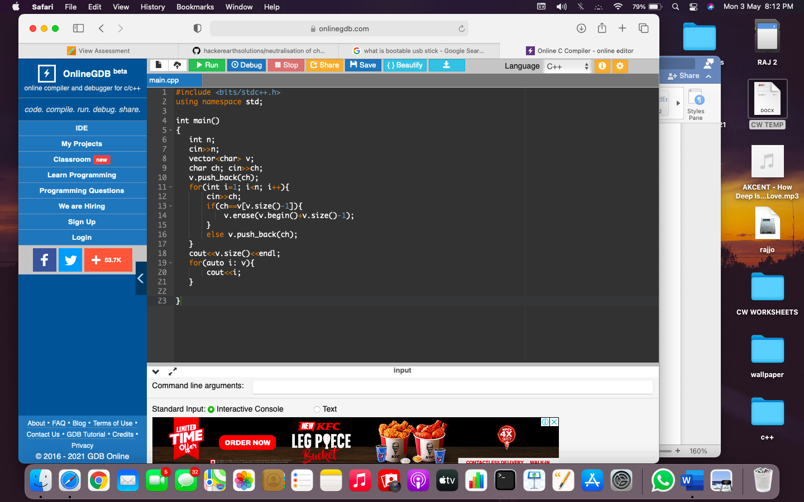

**OUTPUT:**

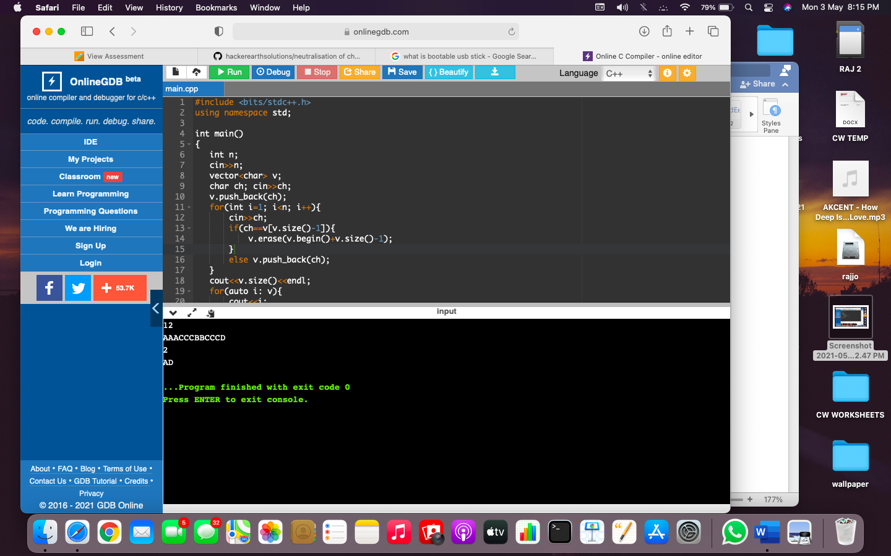

LEARNING OUTCOMES

1. Apply coding skills to solve application based problems on competitive platforms such as Hacker Rank/ Hacker Earth/Code Chef.
2. Understand the basic concept and structure of computer hardware
3. Identify the existing configuration of the computers and peripherals.
4. Installing and uninstalling multiple operating systems on a machine.
5. Apply their knowledge about computer peripherals to identify /rectify problems on-board.

EVALUATION COLUMN (To be filled by concerned faculty only)

|  |  |  |  |
| --- | --- | --- | --- |
| **Sr. No.** | **Parameters** | **Maximum**  **Marks** | **Marks**  **Obtained** |
| 1. | Worksheet Completion including writing learning objective/ Outcome | 10 |  |
| 2. | Post Lab Quiz Result | 5 |  |
| 3. | Student engagement in Simulation/ Performance/ Pre Lab Questions | 5 |  |
| 4. | Total Marks | 20 |  |